**Output:**

# **Name : Rajkumar B L**

# **Reg.No : 2047120**

# **Course : MCS 272 Mobile Application**

# **(Lab 06 – Ankalama PG)**

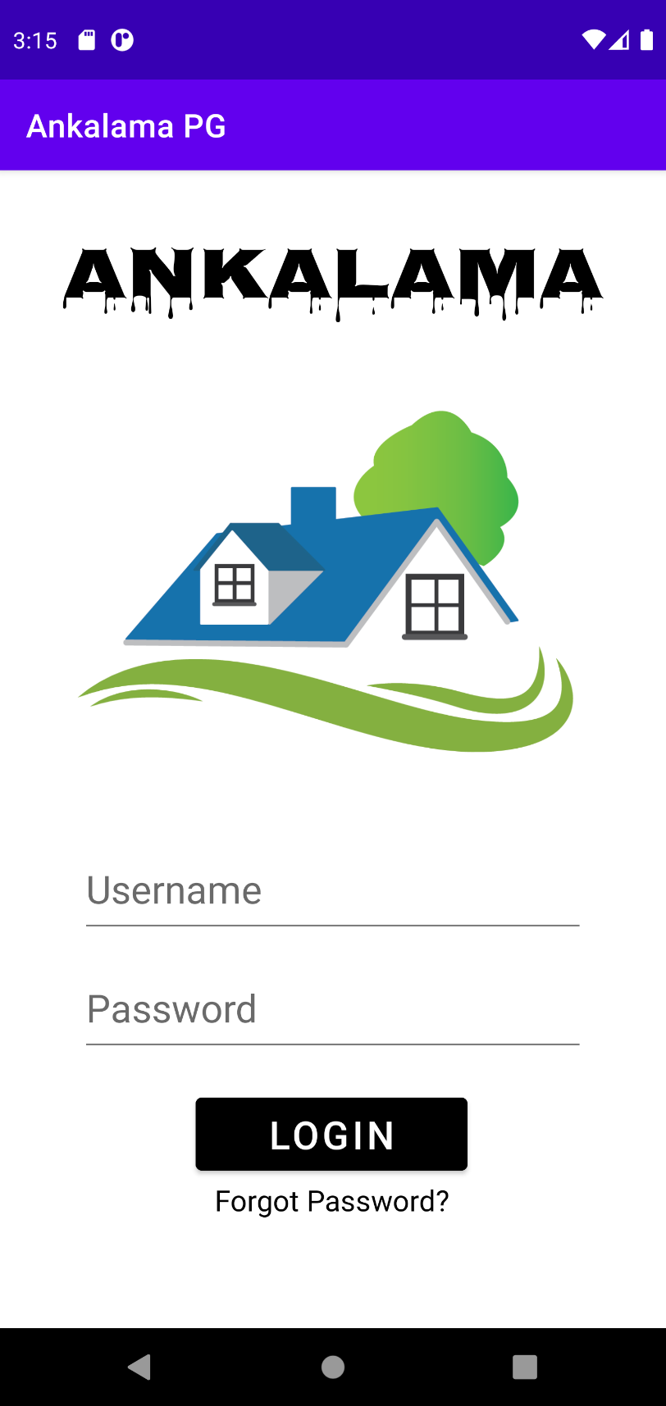1. Splash Screen 2. Welcome Screen

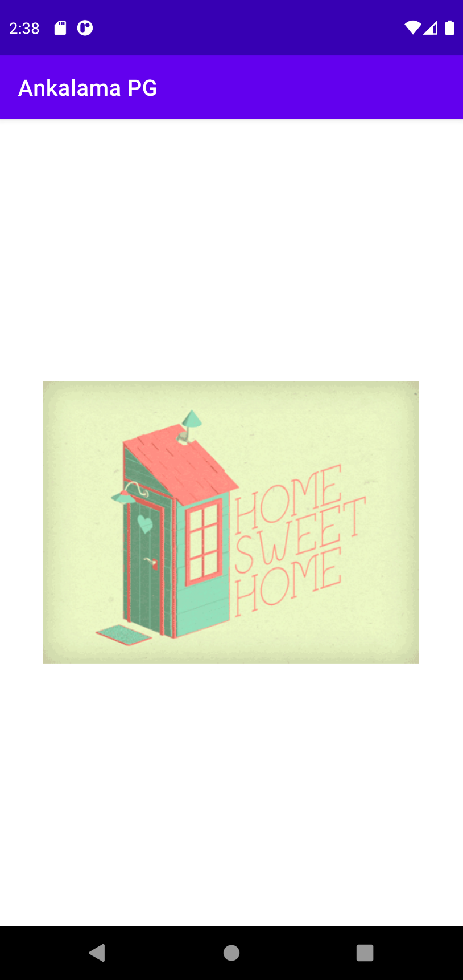

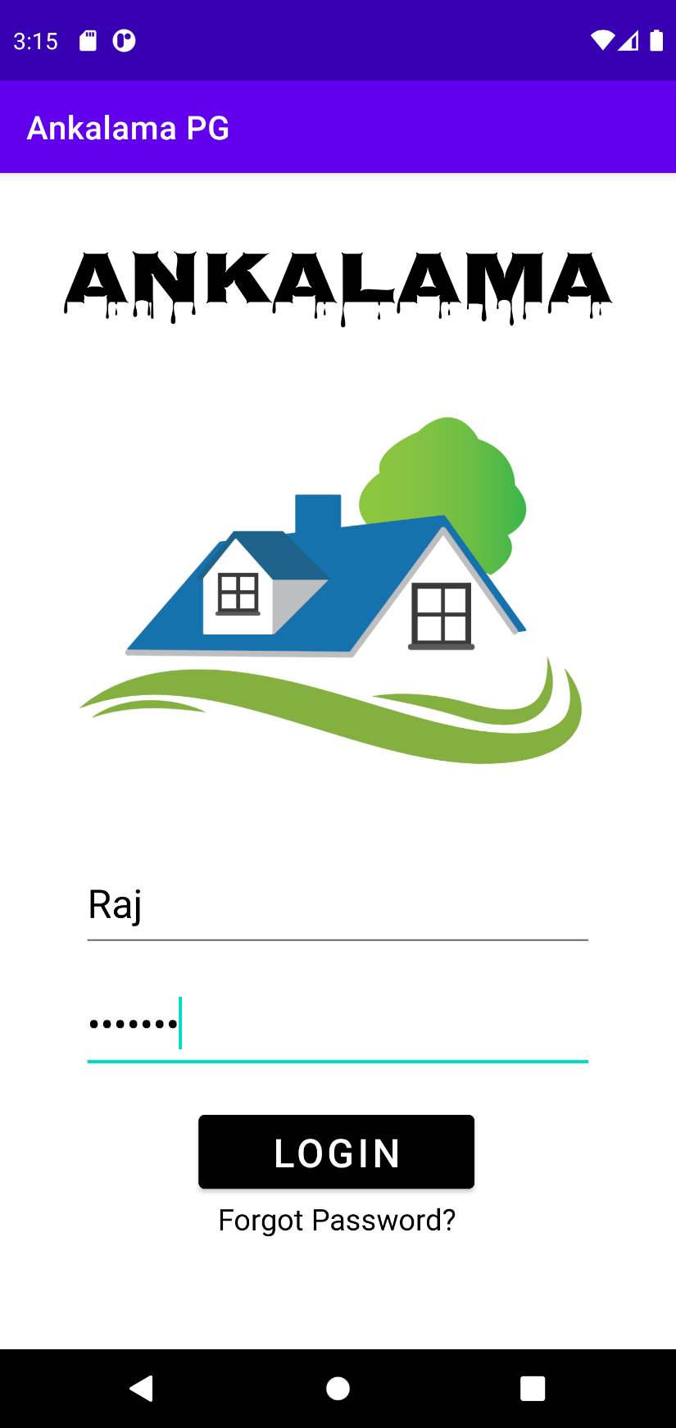3. Login 4. Resident Detail (Option Menu)

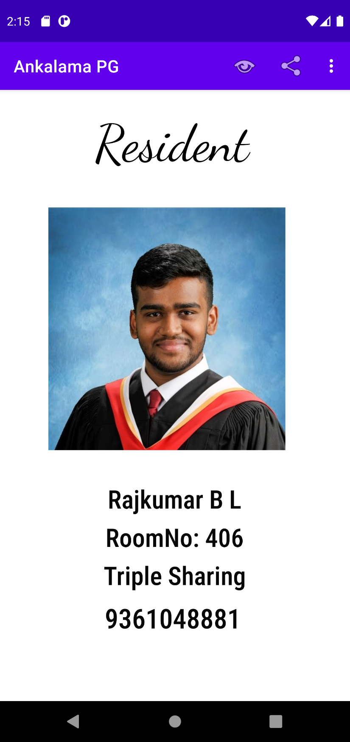

5. Option Overflow 6. Contextual Float Menu

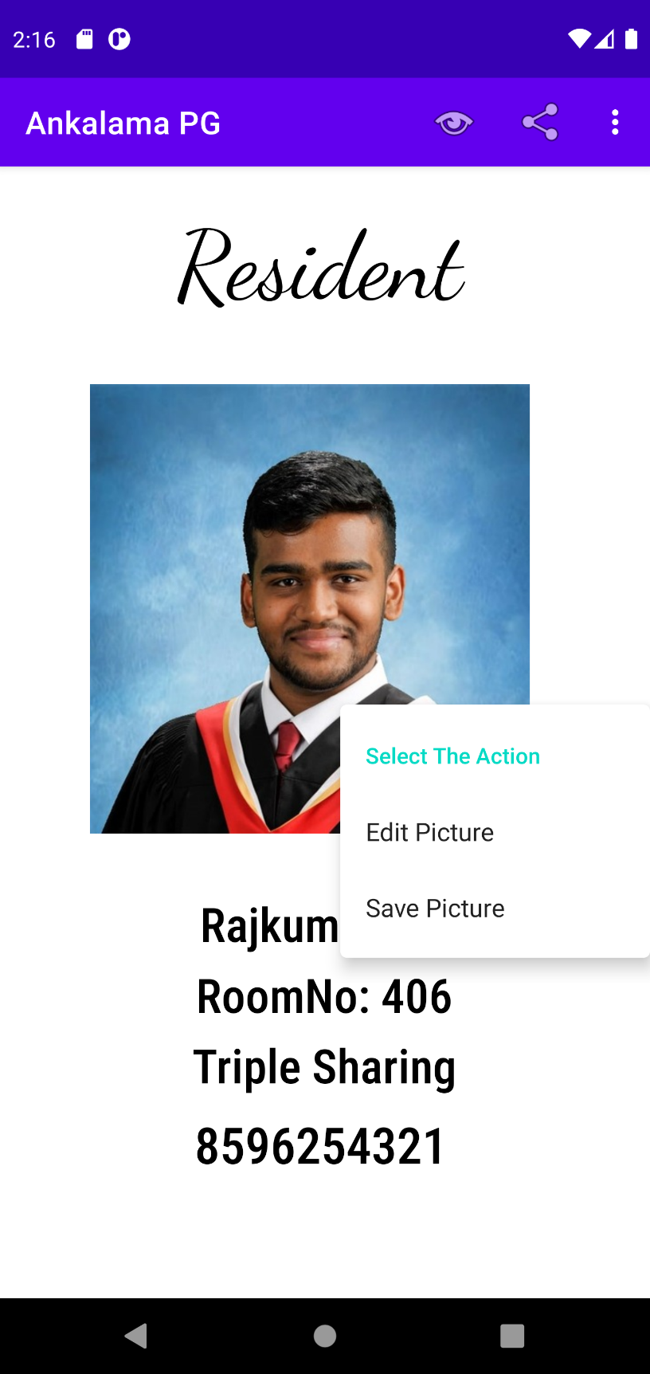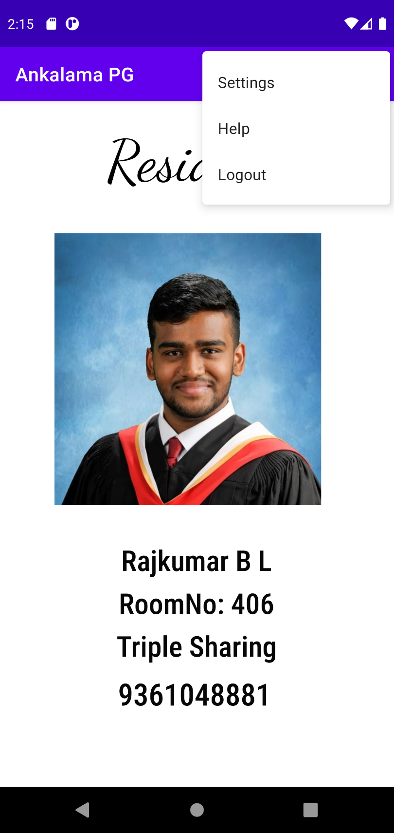

7. Popup Menu(View Modes) 8. Dark Mode

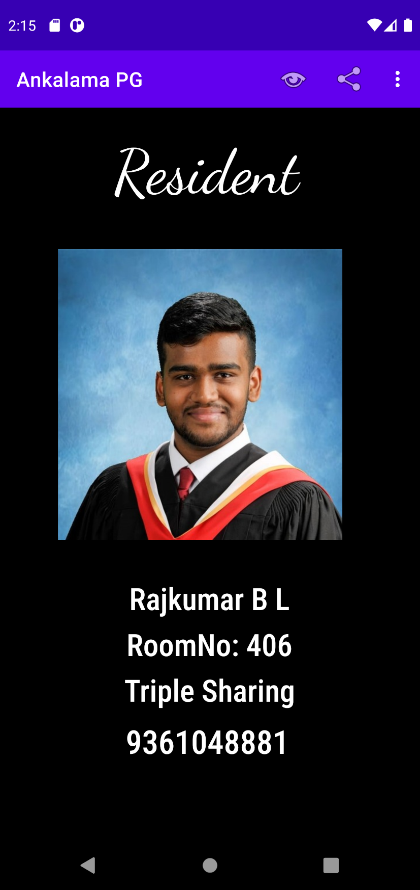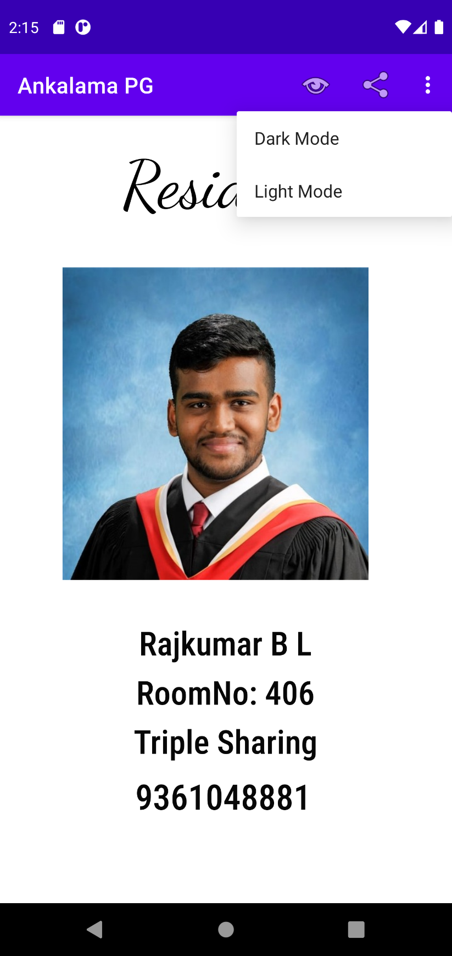

9. Light Mode 10. Contextual Action Menu

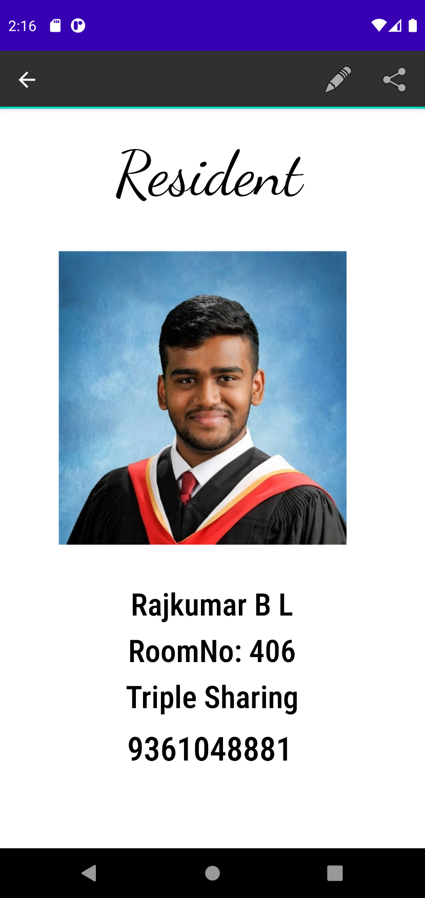 (Phone Number Long Press)

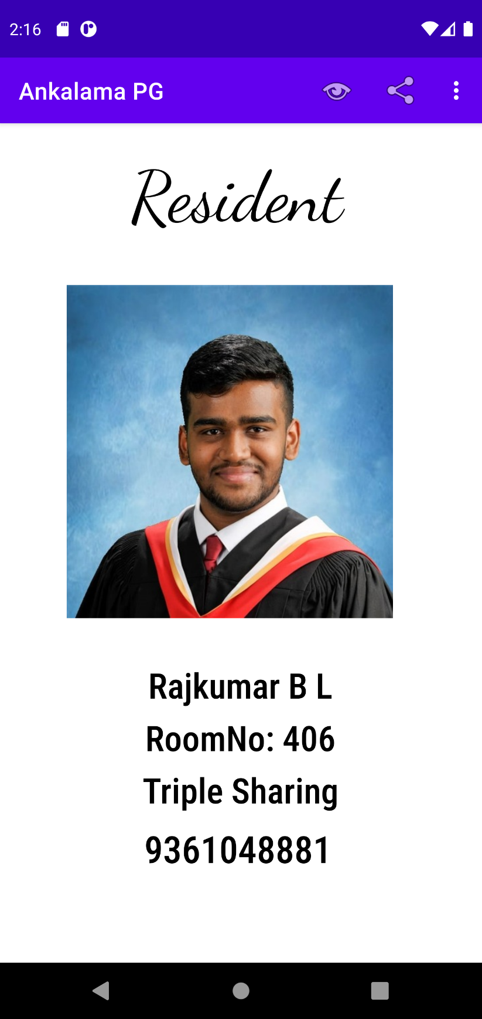

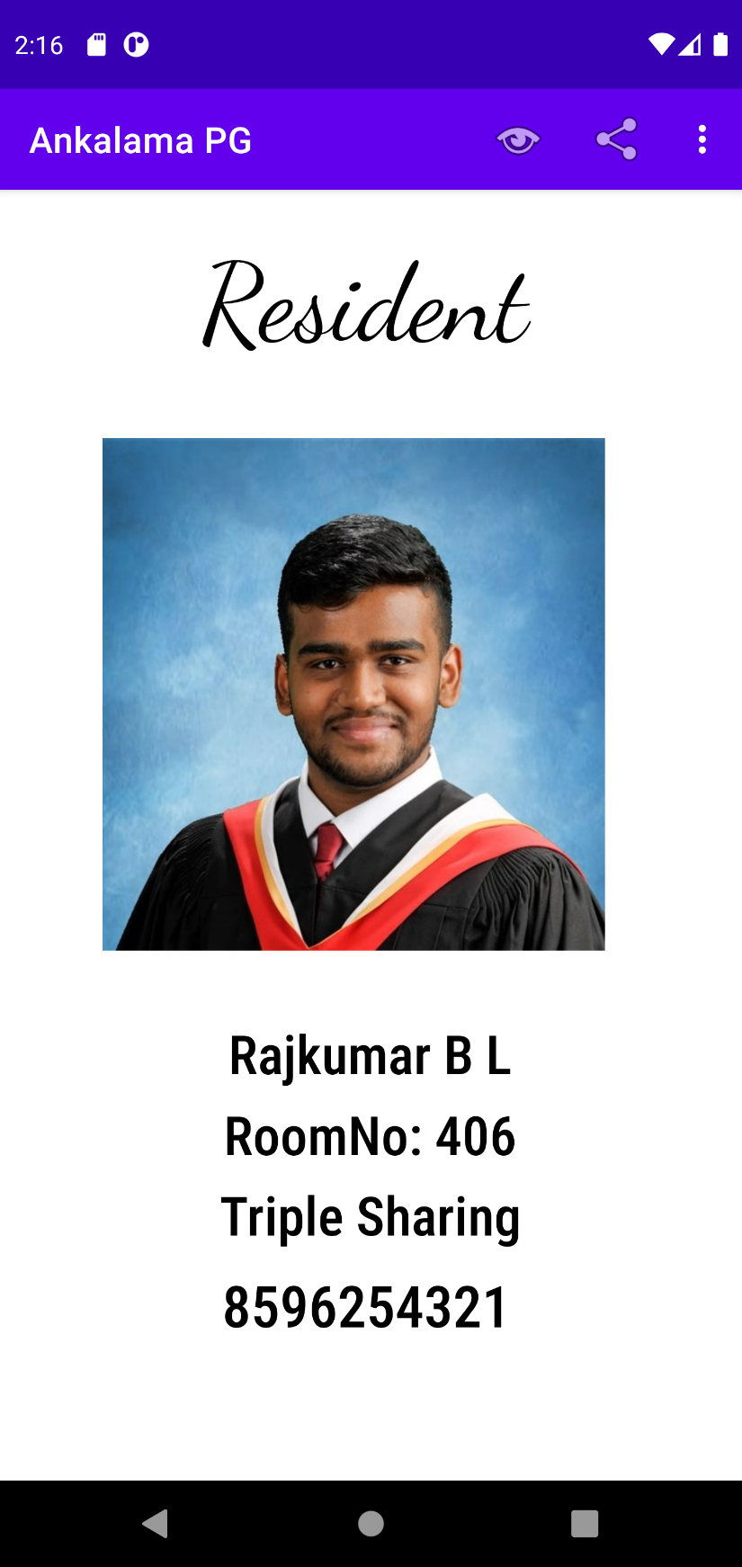11. Edit option enables phone num editing 12. Edited new phone number

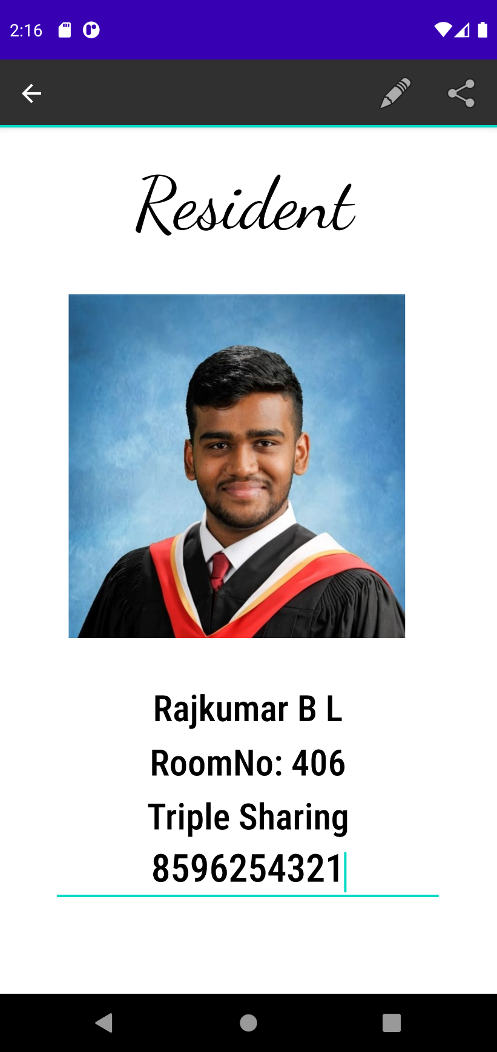

13. Logout – Exit app

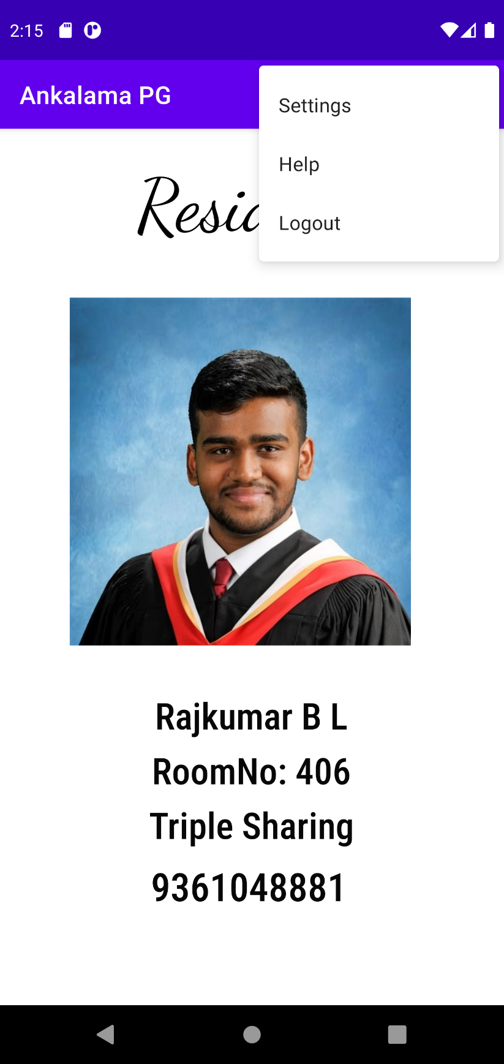

**The code used in the Main Activity, XML layout, Splash scree, button ripple effect is attached below for reference.**